**Website #2**

[**https://www.currys.com/**](https://www.currys.com/)

1.**Interaction Model**

The interaction model of Currys is fairly well maintained, and is fairly straight forward. They have fairly good organization, but the designer did not think of what the user will think when they first go onto the website, I am not really sure where to go to get my items, only after being on the site and looking for a few products am I able to go and navigate to get a product that I am looking for.

**1.User Flow**

From the home page click on category,

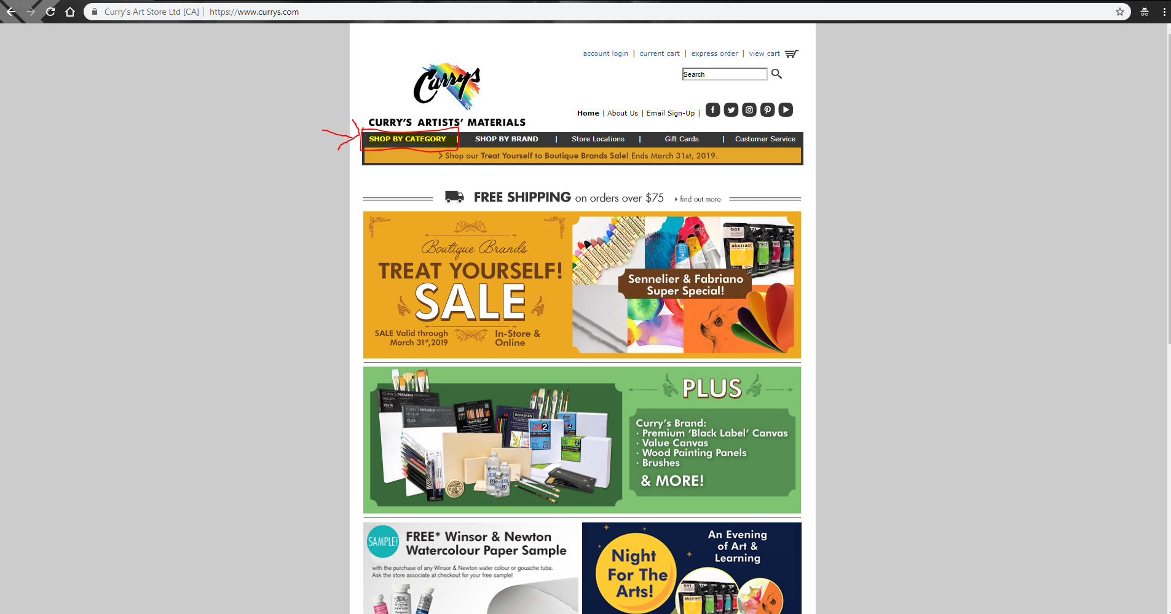

Then from the category, choose the type of appliance you want

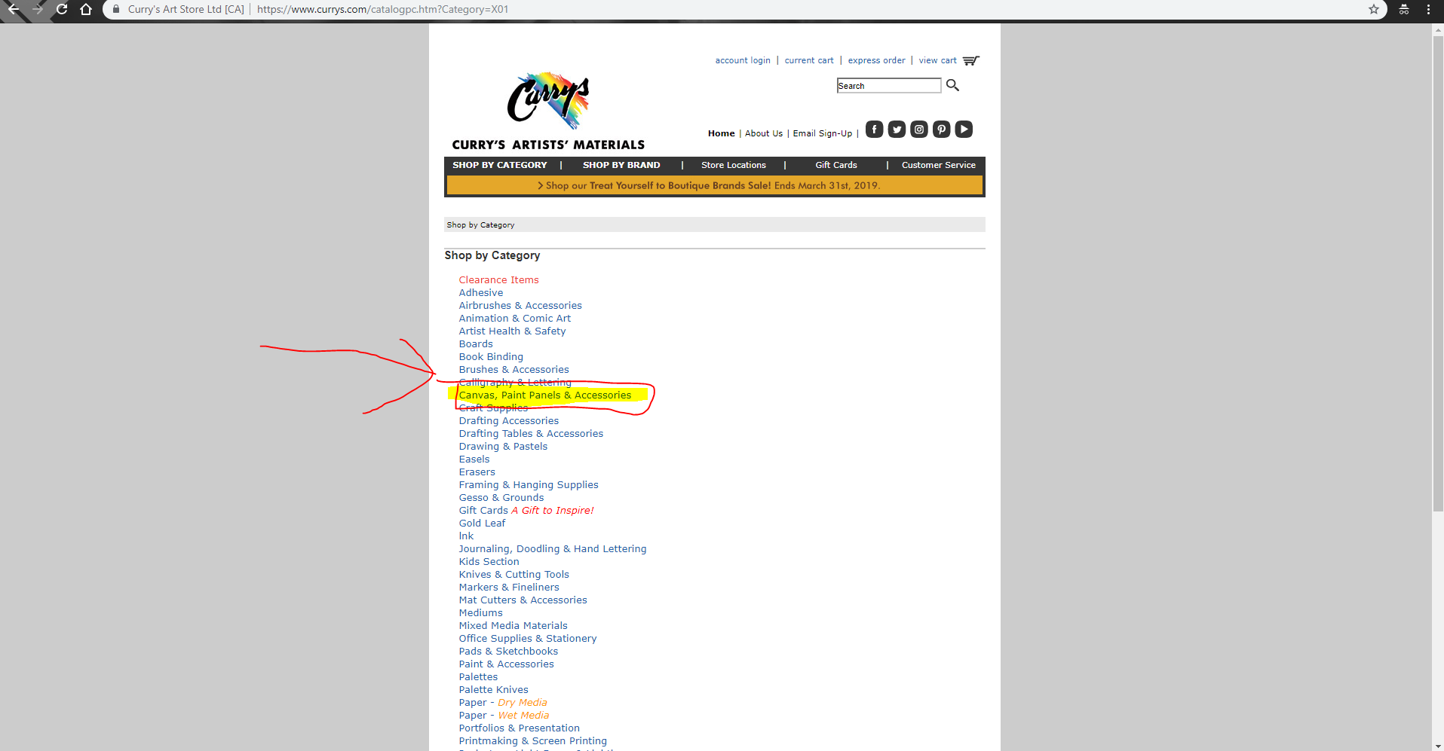

Then from here click on the specific Item you were looking for

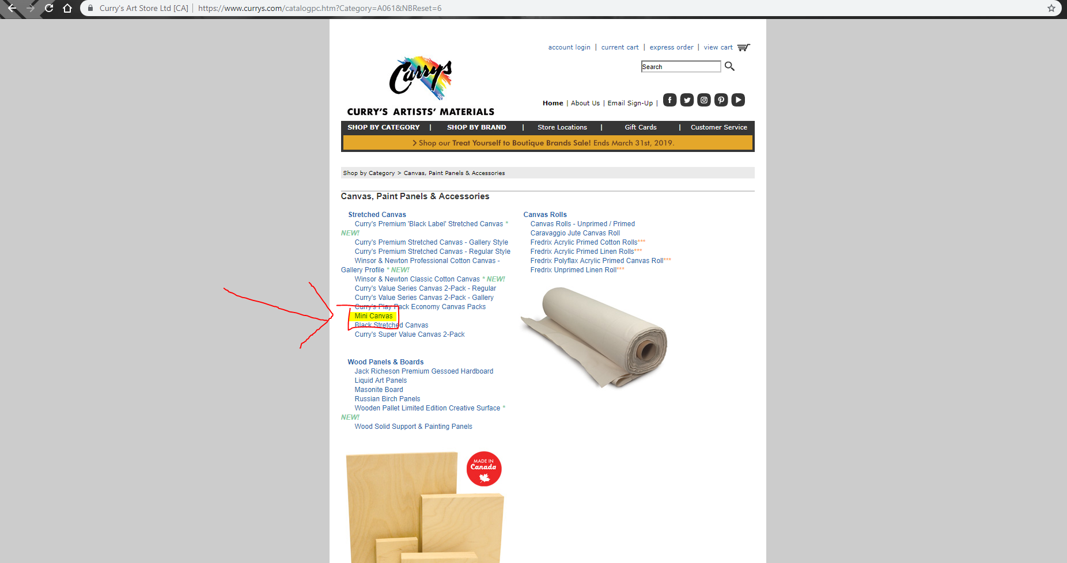

Once I find the product I want, I set the amount I want

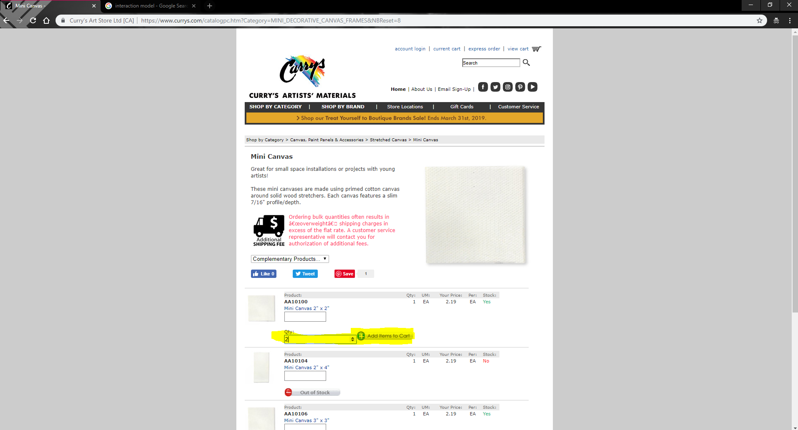

Then click the add to cart button.

Once that is done, I will go to the View Cart button.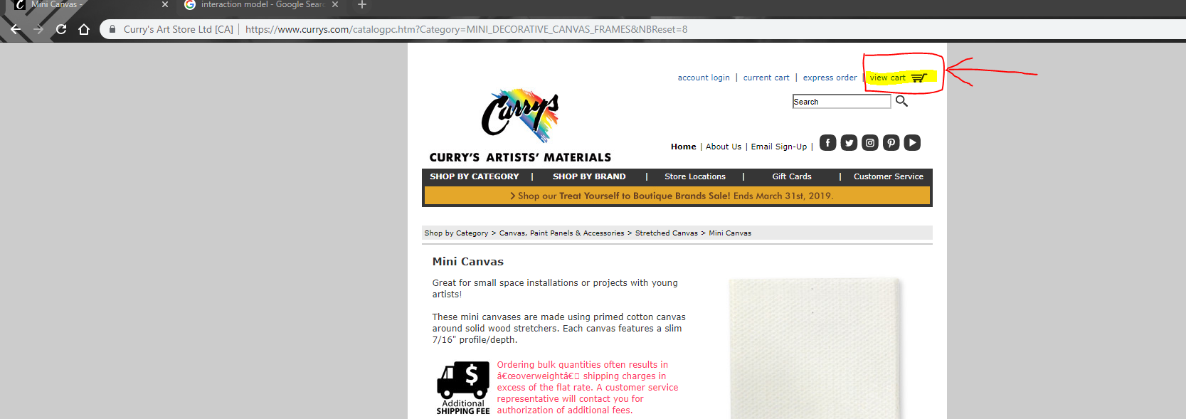

Then fill in the information about your product The

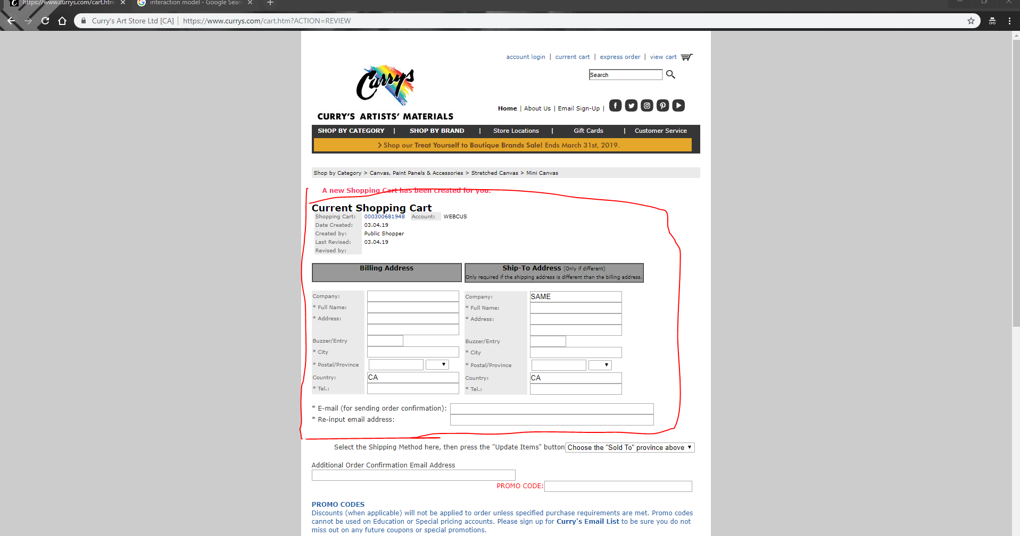

If I want to remove an Item from the cart, you would click remove, and then have to scroll to the bottom and click update items

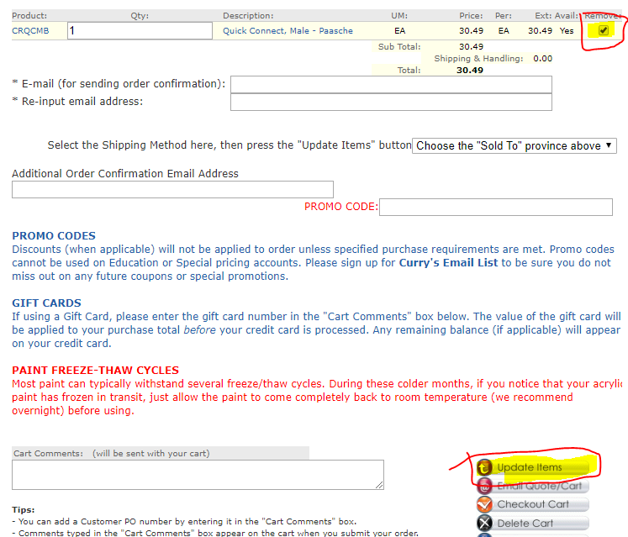

If you are ready, you just click checkout cart

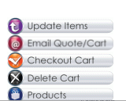and your done

**Q2. Note the ease of interaction with the site**

**Ease of use summery**

* it crashes when I click specific items sometimes
* It has unnecessary pages
* It has blank and ugly pages that make the site less appealing for me to come back
* Duplicates of some links can be removed.
* multiple missteps in the way to check out
* usually when you are adding something to your cart, it is a one click adds one to the cart, this might be confused because the page refreshes so the user might think its in his cart when it is not.
* The billing information needs a look up and needs a change because its not very efficient and is confusing, if its your first time

**Q2 Ease of Use Explained**

The first thing you see while going onto the website is that it pulls your attention to the bright colors of the webpage, this is a very nice idea.

* They clearly have sales and items that are going on sale, allowing users to clearly see what’s on sale and what’s important that’s going on
* I do feel like the website could be spaced out and have more items on the side/make the images wider, because the site feels small and compact(desktop version looks like mobile version

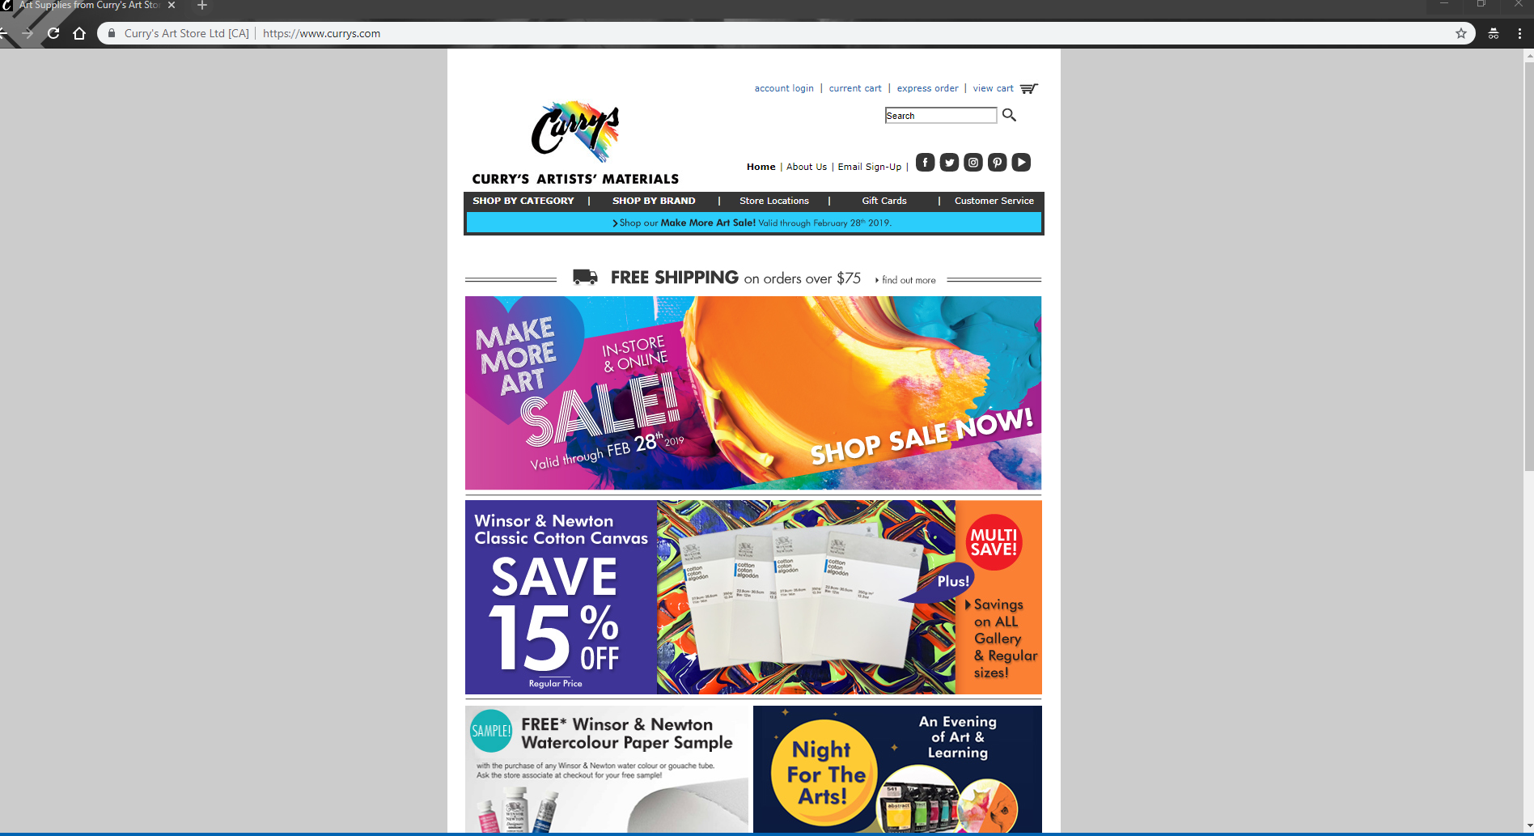

* The way to shop is a lot easier and faster, it has features that a modern website would have
* To purchase or order an item, you can shop by category or shop by brand
* If you shop by category, it sends you to a blank page that is very plank and ugly, and needs some work, it does follow the trend that the website has, but it looks ugly the way they did it. (they could have also incorporated it into the nav bar itself)

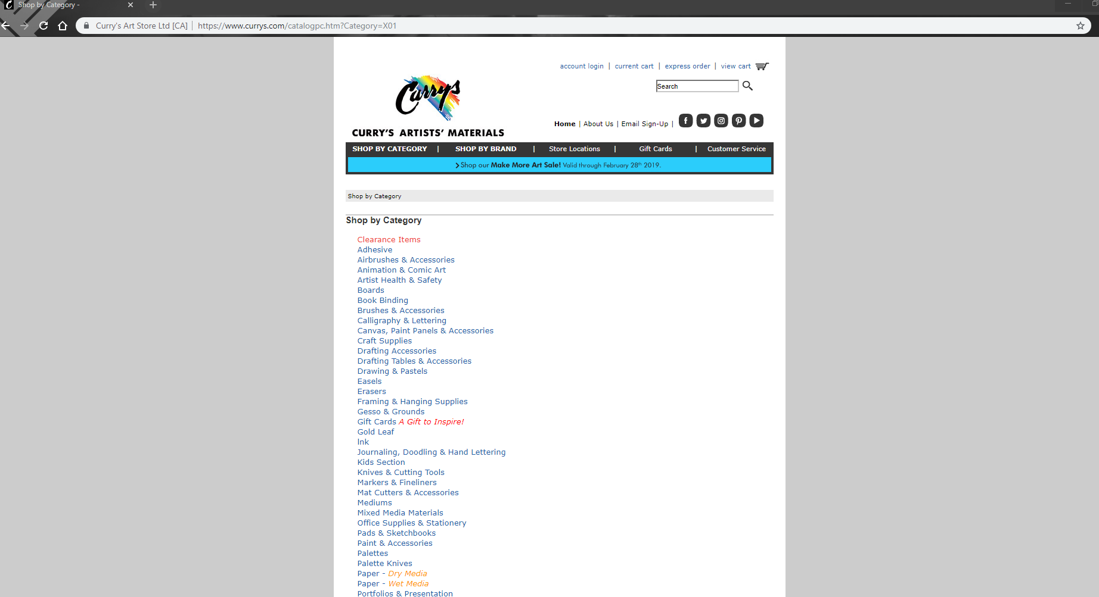

* To shop by Brand is a similar to the shop by category, but is a little more organized,
* the font is too small, and should be bigger,
* In the shop by brand, there some have pictures, others do not and are just a link to other links of items, this is not very innovative and should be changed to incorporate pictures of the products so people would see and recognize that that is the item they used last time so they don’t have to remember the name, but the color and logo of the item
* I ran into an error when navigating a product

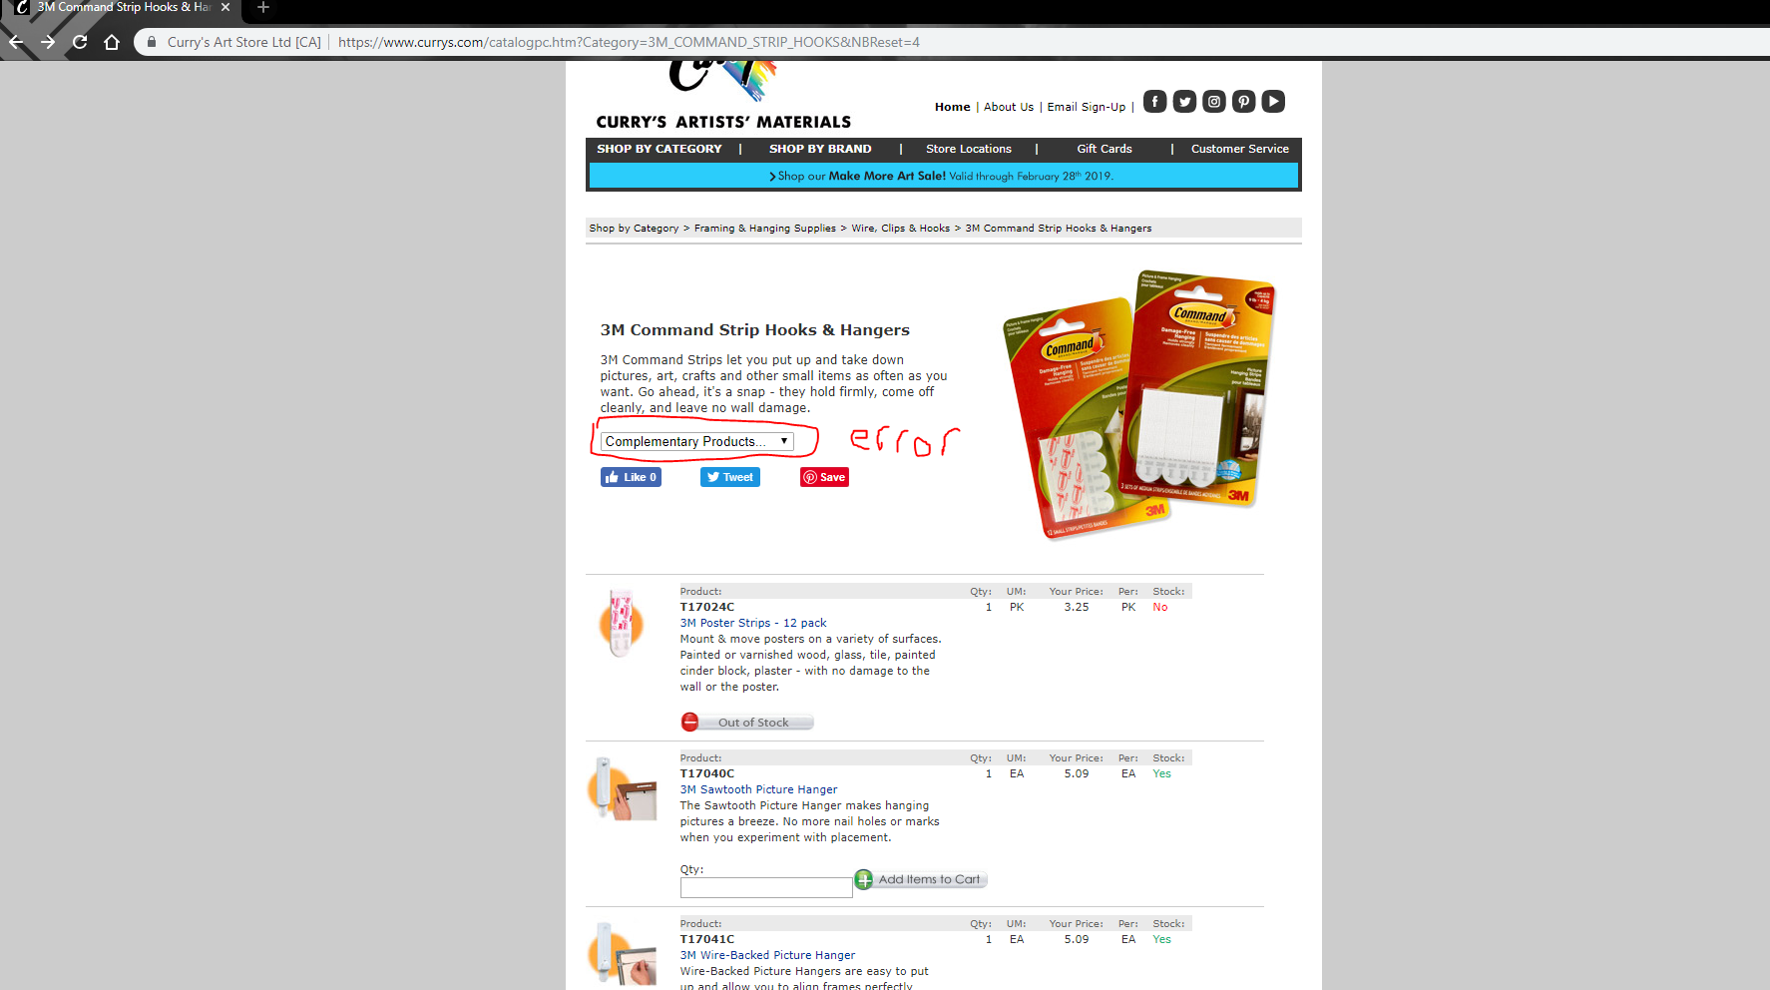

The error page displayed

* 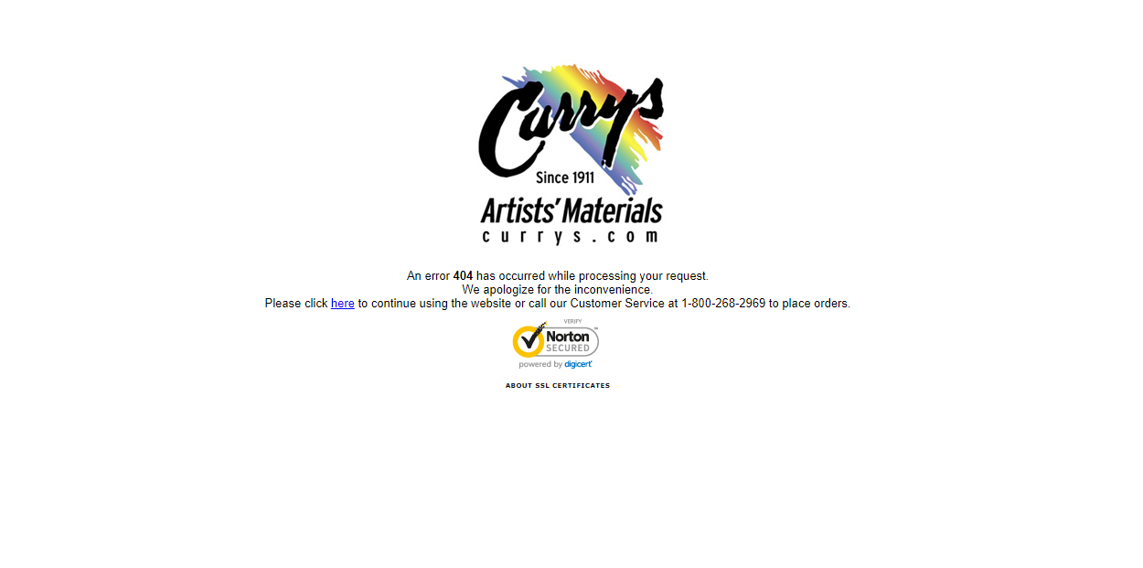
* When you click add to cart, it does not default to one, it defaults to 0 and displays that no products were added to my cart, this should just give you a message saying please enter a qty
* Current cart and view cart are the same thing. Take one out, or replace it with my cart, or checkout
* When I enter the billing or view my shopping cart the billing items are on top and should be below because I want to see my cart before I put all of my information into the billing address, so when I see a mistake in my order and have to fix it or change it I don’t have to re input my billing information.
* When I try to remove an Item I click the remove box and the item does not remove, and it does not remove it from the screen. I tried to refresh the page, but it does not remove the items when I click remove.
* After a bit of investigating, at the bottom of the page there is a update items button that will update your cart along with other unnecessary buttons
* 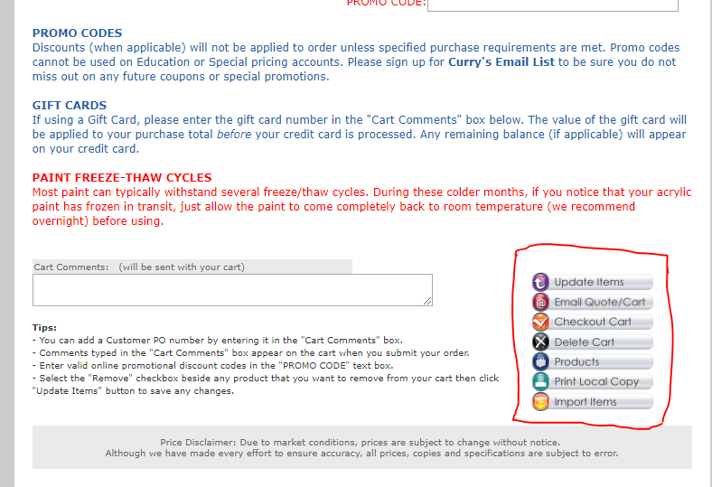
* The checkout button is way too small compared to the others, it should be bigger and not in a list of other commands, especially delete cart, due to you accidentally deleting your cart instead of checking out.

**Q3 Pain points summery**

1. Has some pages that are very bland and should be changed to look more interactive or to follow the other
2. Some Links don’t need to be there because there is another link that does the same thing
3. Login System is only for people who apply *AND get accepted(teachers/schools)
4. Adding to cart does not default to one, and gives an illusion that you successfully did it
5. Layout of the payments on the Webpage
6. Layout of items effecting the webpage are not efficient on the Checkout webpage
7. Some on the Checkout page should be taken out because regular customers do not know how to use it and it should be taken out because it can be confusing
8. Buttons throughout webpage look out of place and are ugly(looks like a different resolution compared to rest of the page)
9. There are some inconsistencies while browsing categories and brands

**Q3. Note the pain points (full explanation)**

* it has a few unnecessary pages that require extra clicking, they are very bland and should either be removed, or should be placed into the navigation bar as a dropdown

example of a page that and should be changed or removed into a nav bar

* some links send you to the same place. And are not needed as highlighted in the picture

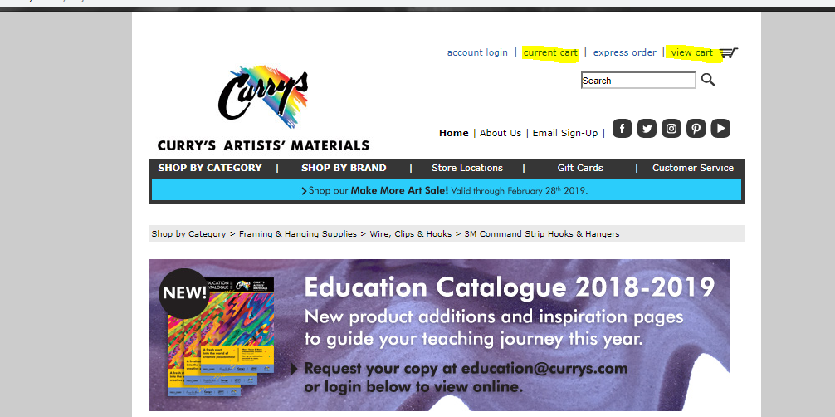

* another thing would be that the login system is only for schools with an education account, and you have to set up an account by emailing the website for an application. This is not the way I would use the login system and I would expand it to all users so they can buy products faster and more efficiently
* While browsing products, when you click add to cart, it does not default to one, it refreshes the page and then displays in red text.no products were added to my cart, this should just give you a message saying please enter a qty in the box instead of updating the html.

No quantity before

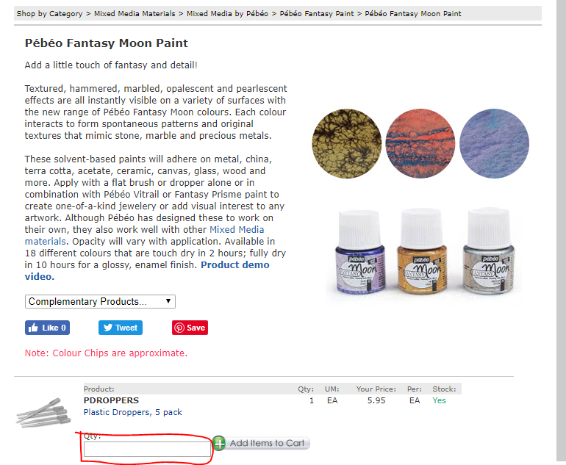

No quantity after

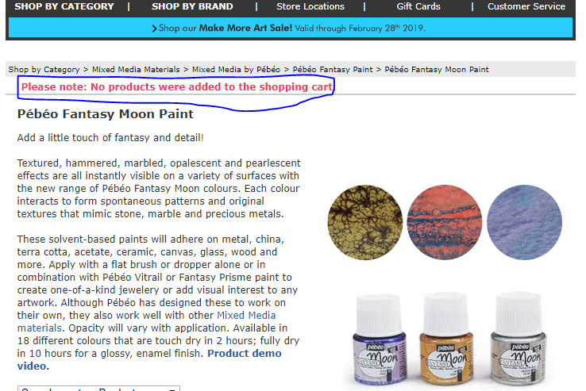

* Another problem with updating the html, is that it is especially confusing because it would put the same color text when you do add an item to your cart

Adding Three to my cart

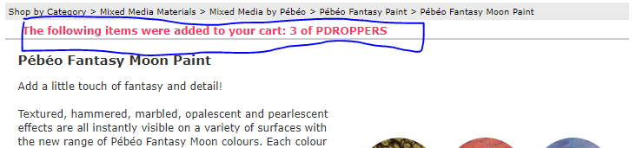

* I don’t see a point for the user to see the current shopping account **(shown in red)**
* When I enter the billing or view my shopping cart the billing items are on top and should be below. This is because I want to see what’s in my cart before I put all of my information into the billing address, so when I see a mistake in my order and have to fix it or change it I don’t have to re input my billing information. (**Shown in blue)**

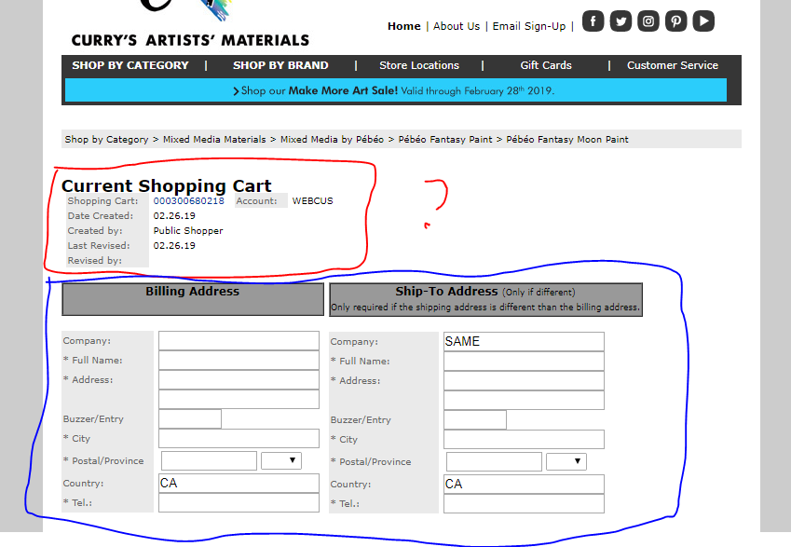

* When I scroll down I can see my shopping cart, but when I try to remove an item it does not remove when I click the remove checkbox.

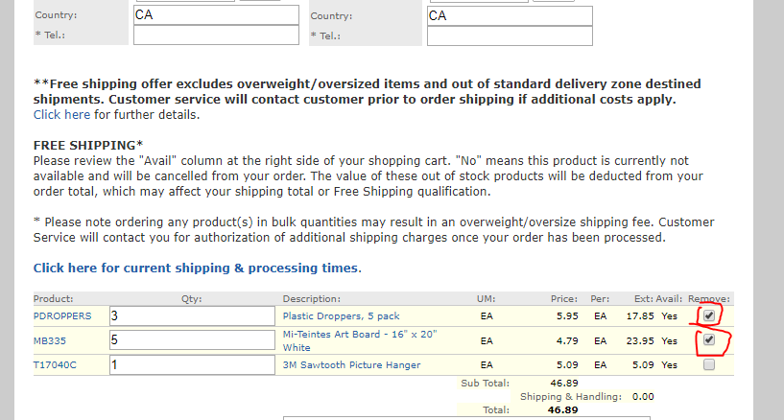

* When I try to remove an Item I click the remove box and the item does not remove, and it does not remove it from the screen. I tried to refresh the page, but it does not remove the items.
* You have to scroll to the very bottom right of the page to click a button to get/update information in your cart

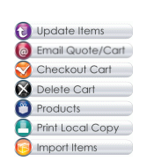

* I would change the look of the buttons and change the location because it looks old and should look more modern
* I would also change the add to cart button because it looks really out of place and weird because its resolution looks way worse then the rest of the website

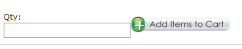

* The options highlighted are not of use and are useless. These would not be used by users and is a waste of space and organization of the website

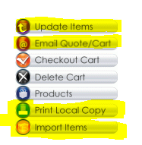

* Update items should not be there because it should automatically do that when you change or remove an item.
* Email or quote/cart could be implemented better by using a url and just sending a link to the other person instead of using an emailing service to send an email to someone you know.
* Print Local copy, is not needed because there could be a checkbox option if you want to send yourself an email of the receipt and where you shipped it
* And I have no idea how to use the import items button, it does not explain anything and looks really confusing

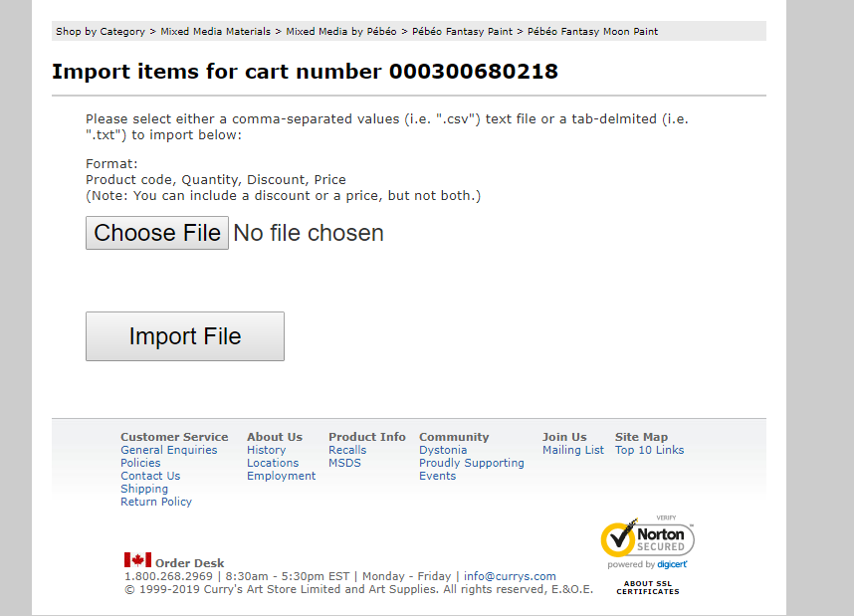

* There are some inconsistencies while browsing categories and brands, that include some one direct link, others having multiple links, and some having inconsistent links and random pictures at the end

Direct links by Brand SHIVA

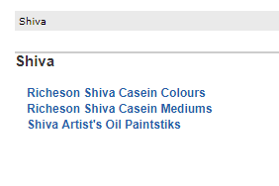

Direct links by brand Amsterdam

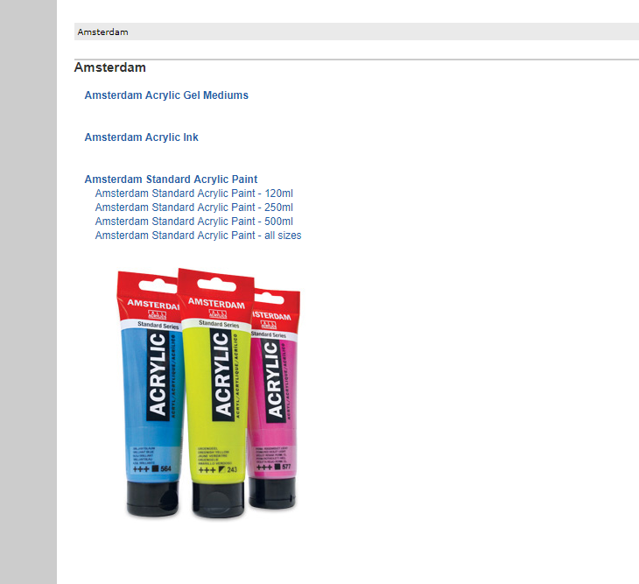

**Q4.revisit the site and give recommendations on improving the interaction, layout**



1. The first thing I would do is change the items so that there are no overlapping links, so people don’t have an option to click a link where it will take them to the same webpage.
   1. I would also change the layout of the top of the page so that account is on its own line as well as the Home ,About us, email sign up and the social media to be separate

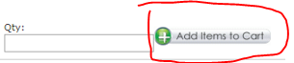

1. Change the weird look of the button and make it look incorporated into the website

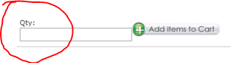

1. The option should have a 0 in it or make the default 1

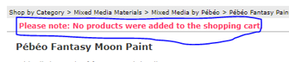

1. Change the input so it is bigger or prompts the user with an JavaScript alert, so user is not confused if he added one or not

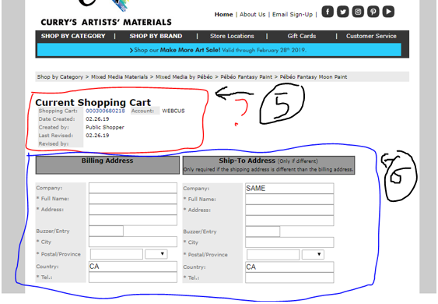

1. I would remove the current shopping cart,
2. I would relocate the payment option, either making flow, page by page, or making the payment at the bottom, so you can make sure you have all your items



1. Make sure that when you click remove, it automatically removes the items without you having to click refresh cart

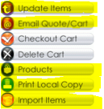

1. Remove unnecessary buttons that may only cause confusion(all highlighted), and also make the icons look more updated and flow with the website more



1. Fix up any browsing inconsistencies and make sure that the webpage looks and feels smooth

**5. What type of improvements beyond the site would you recommend?**

* I would recommend that they make the account login, for all users, not just educational schools/ teachers who take the time to apply and make one. This would be nice because they could be able to see their last purchases, which might help them find the product again if they liked it and save the billing information, so they don’t have to re input all of the information again if they forget something in the billing.

**6.What type of improvements or features would be recommended for repeat users**

* a login system that allows every user to easily make an account. And use that account to remember their location, billing information,